Lab 1-1 Setting Up the Development Environment
Goals | To set up a development environment before beginning to build Siebel Analytics requests and Intelligence Dashboards.
Scenario | Your Siebel Analytics implementation team has already built a Siebel Analytics repository and the underlying data sources to support it. Before beginning development of Siebel Analytics requests and Intelligence Dashboards, you must configure your system for development. You copy and paste the existing repository to the correct folder, create a new, empty Web Catalog to store your requests and dashboards, and modify the appropriate configuration files.
Outcome | AppDevAdv repository is in the correct repository folder; NQSConfig.ini is modified to point to the AppDevAdv repository; a new, empty Web Catalog is created; instanceconfig.xml is modified to point to the new Web Catalog.
Time | 15 – 20 minutes
Environment | 
Instructions:
- Stop the Siebel Analytics services before making changes to your development environment.
  - Select Start > Programs > Administrative Tools > Services.
  - Stop the Siebel Analytics Web service.
  - Stop the Siebel Analytics Server service.
  - Verify that the Siebel Analytics Scheduler service is stopped.
- Copy and paste the AppDevAdv repository to the appropriate Siebel Analytics repository folder.
  - Navigate to C:\Data\ANADV.
  - Copy AppDevAdv.rpd.
  - Paste into C:\SiebelAnalytics\Repository.
- Modify NQSConfig.ini file so that the Siebel Analytics Server loads the AppDevAdv repository.
  - Navigate to C:\SiebelAnalytics\Config.
  - Double-click NQSConfig.ini.
  - Locate the Repository Section.
  - Modify the file to load the AppDevAdv repository. Your results should look similar to the following:
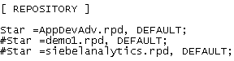
  - Save and close NQSConfig.ini.
- Create a new Web Catalog folder to store a new, empty Web Catalog.
  - Navigate to C:\SiebelAnalyticsData\Web.
  - Rename the Catalog folder to Catalog_Backup.
  - Create a new folder named Catalog in C:\SiebelAnalyticsData\Web. When you start and stop the Siebel Analytics Web service in a later step, a new Web Catalog called default.webcat will be created in this Catalog folder.
- Verify that the file instanceconfig.xml has the correct Web Catalog path.
  - Navigate to C:\SiebelAnalyticsData\Web\config.
  - Make a backup copy of instanceconfig.xml. Please note: Always make a backup copy of the file instanceconfig.xml before making any changes.
  - Right-click instanceconfig.xml and open with Notepad.
  - Change the catalog path to C:/SiebelAnalyticsData/web/catalog/default.webcat. Your file should look similar to the following:
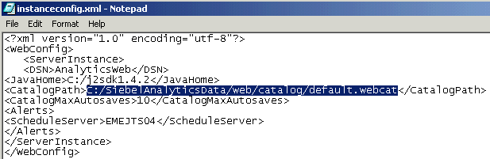
  - Save and close instanceconfig.xml.
- Restart the Siebel Analytics services to apply your changes.
  - Restart the Siebel Analytics Server and Siebel Analytics Web services. There is no need to restart the Siebel Analytics Scheduler service because it is not used in the labs for this course.
  - Navigate to C:\SiebelAnalyticsData\Web\Catalog.
  - Verify that a default.webcat.version file and a default.webcat.10.autosave file were created in the Catalog folder. By default, Siebel Analytics Web performs a Web Catalog backup every five minutes. The version file contains information about the last known good Web Catalog backup.
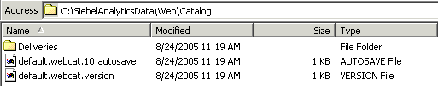
  - Stop the Siebel Analytics Web service. This creates a new Web Catalog in the Catalog folder.
  - Navigate to C:\SiebelAnalyticsData\Web\Catalog.
  - Verify that a new Web Catalog called default.webcat was created in the Catalog folder.
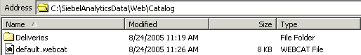
Please note: You will learn more about managing and administering the Web Catalog later in this course.
  - Start the Siebel Analytics Web service.
Lab 1-2 Combining Requests Using Set Operations
Goals | To combine the results of two requests using union, union all, intersect, and minus set operators.
Time | 10 – 15 minutes
Instructions:
- Log in to Siebel Analytics as Administrator. For most of the labs in this course you will log in to Siebel Analytics as Administrator. Any user can combine requests using set operations, provided that the Administrator has granted the user this privilege.
  - Select Start > Programs > Siebel Analytics > Siebel Analytics Web.
  - Log in to Siebel Analytics as Administrator with password Administrator.
- Combine criteria from multiple requests using the Union set operator.
  - Click the Answers link to navigate to the Answers start page.
  - Select the SupplierSales subject area.
  - Create the following request and filter:
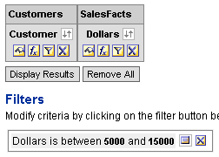
  - Click Combine with Similar Request. The Subject Area dialog box appears.
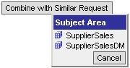
  - Select the SupplierSales subject area. The Set Operations page appears.
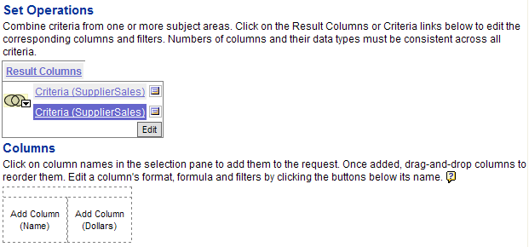
  - Click column names in the selection pane to create the following request and filter:
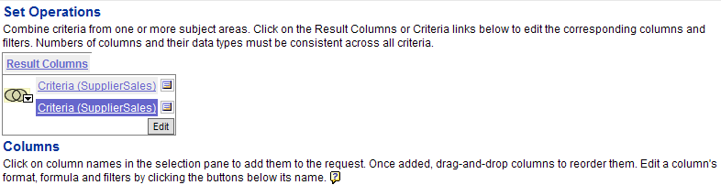
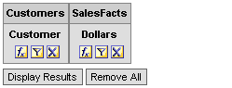
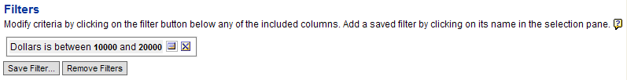
Please note that the number of columns and data types must be consistent.
  - Click the Set button and select the Union set operator (Union is the default).
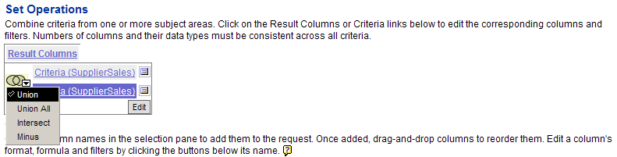
  - Click the Results tab to display the combined, non-duplicate rows (union) from all requests. In this example, the table displays all customers with revenue between five thousand and twenty thousand.
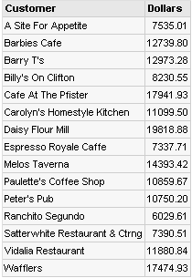
- Combine criteria from multiple requests using the Union All set operator.
  - Click the Criteria tab to return to the Criteria view.
  - Click the Set button and select the Union All set operator.
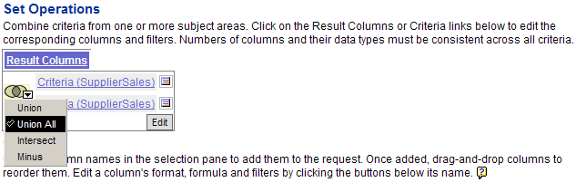
  - Click the Results tab to display all rows from all requests (union all). In this example, the table displays all customers with revenue between five thousand and twenty thousand, and includes dollar values that meet criteria from both requests.
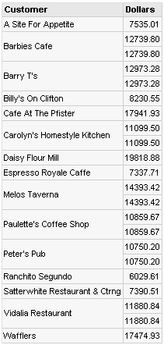
- Combine criteria from multiple requests using the Intersect set operator.
  - Click the Criteria tab to return to the Criteria view.
  - Click the Set button and select the Intersect set operator.
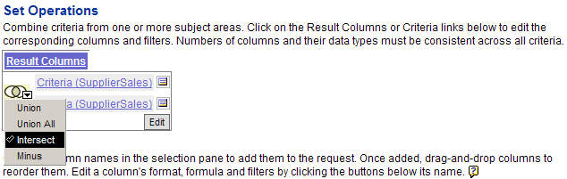
  - Click the Results tab to display all rows that are common to both requests (intersect). In this example, the table displays all customers with revenue between ten thousand and fifteen thousand.
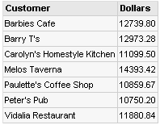
- Combine criteria from multiple requests using the Minus set operator.
  - Click the Criteria tab to return to the Criteria view.
  - Click the Set button and select the Minus set operator.
  - Click the Results tab to display all rows from the first request that are not in the other request (minus). In this example, the table displays all customers with revenue between five thousand and ten thousand.
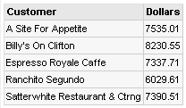
- Leave Siebel Answers open for the next lab.

Lab 1-3 Executing a Direct Database Request
Goals | To create and issue a database request directly to a physical back-end database.
Scenario | Use Siebel Answers to set the appropriate privilege to execute direct database requests and then create, display, and manipulate a direct database request.
Time | 15 – 20 minutes
Instructions:
- Set the privilege to allow the Administrator user to create and issue direct database requests. Any user can execute a direct database request, provided that the Administrator has granted the user this privilege.
  - Click the Admin link. The Siebel Analytics Web Administration window opens.
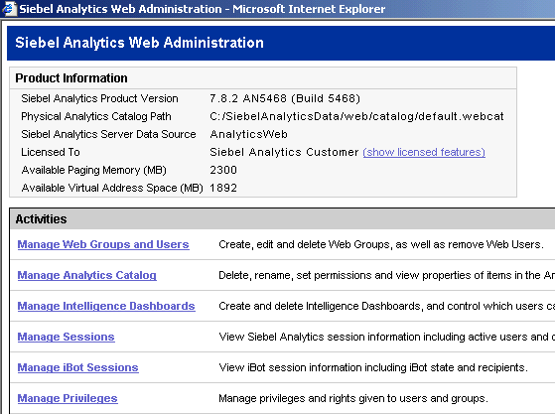
  - Click the Manage Privileges link. The Privilege Administration window opens.
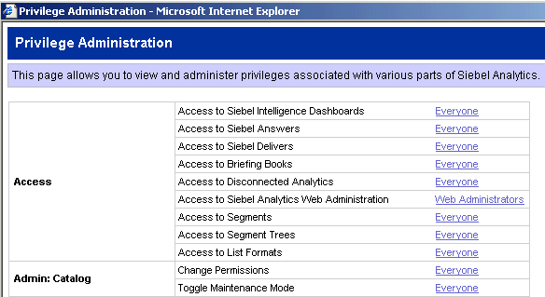
  - Scroll to the Siebel Answers section.
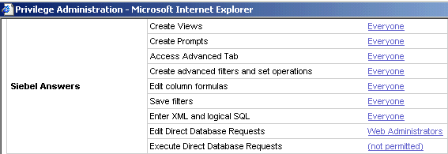
  - Locate the Execute Direct Database Requests privilege.
  - Click (not permitted). The Change Privilege Permissions window opens.
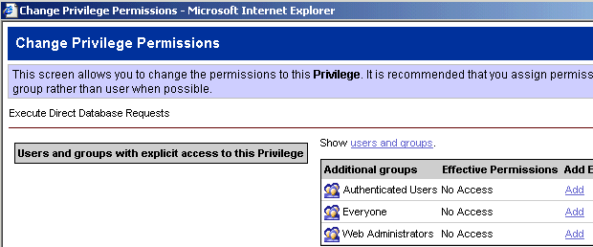
  - Click the users and groups link.
  - Next to Administrator, click Add to give the Administrator the privilege to execute direct database requests.
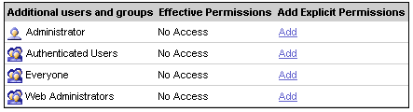
  - Click Finished in the Change Privilege Permissions window.
  - Click Finished in the Privilege Administration window.
  - Click Close Window in the Siebel Analytics Web Administration window.
- Create and execute a request in Siebel Answers. You will compare the results of this request with the results of a direct database request in the next step.
  - Click the Answers link
  - Select the SupplierSales subject area.
  - Create the following request and associated filters:
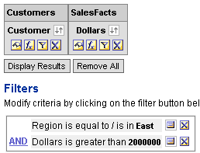
Please note: Delete the Region column from the request after creating the filter.
  - Click Results and verify that the following results are returned:
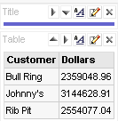
- Create and execute a direct database request.
  - Click the Answers link.
  - On the Answers start page, click Create Direct Request.
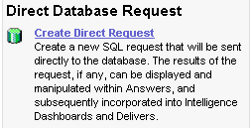
  - In the Connection Pool field, type “SUPPLIER CP”. Include the double quotes. This is the name of the connection pool specified in the Physical layer of the repository.
  - In the SQL Statement field, enter the following SQL statement:
SELECT D1_customer2.Name, sum(D1_Orders2."ActlExtnd")
FROM D1_Customer2, D1_Orders2
WHERE (D1_Customer2."NewKey" = D1_Orders2."CustKey" and D1_Customer2."Region" = 'East')
GROUP BY D1_Customer2."Name"
having 2000000 < sum(D1_Orders2."ActlExtnd")
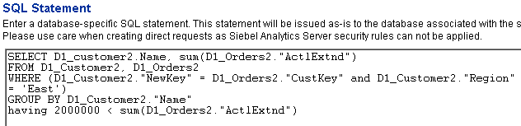
  - Click Validate SQL and Retrieve Columns and verify that the appropriate columns appear under Result Columns:
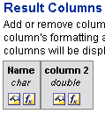
  - Click the Results tab and verify that the same results from the previous step are returned:
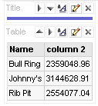
- Leave Siebel Answers open for the next lab.
Lab 1-4 Editing Logical SQL Generated for a Request
Goals | To examine and edit the logical SQL generated for a Siebel Answers request.
Scenario | Edit the logical SQL for a request after an underlying presentation object has been changed.
Time | 15 – 20 minutes
Instructions:
- Create and execute a request, and examine the SQL generated by the request.
  - Click the Answers link and the SupplierSales subject area.
  - Create the following request and associated filters:
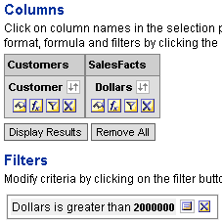
  - Click the Results tab.
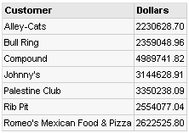
  - Click the Advanced tab.
  - In the SQL Issued field, examine the SQL that was issued to the Siebel Analytics Server when the request was generated.
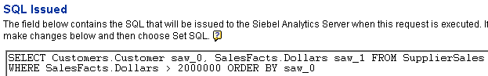
  - Copy the SQL and paste it to Notepad.
  - Save the Notepad file as SQL_Edit on your desktop.
  - Save the request in My Folders as SQL_Edit.
- Change the Customer Presentation layer object in the repository.
  - Log out of Siebel Analytics.
  - Stop the Siebel Analytics Server and Siebel Analytics Web services.
  - Navigate to C:\SiebelAnalytics\Repository and double-click AppDevAdv.rpd to open the repository in the Siebel Analytics Administration Tool.
  - Log in as Administrator/Administrator.
  - In the Presentation layer, expand SupplierSales.
  - Expand Customers.
  - Double-click Customer.
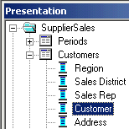
  - In the Presentation Column – Customer properties window, click the General tab.
  - Deselect Use Logical Column Name.
  - In the Name field, delete Customer and type Name.
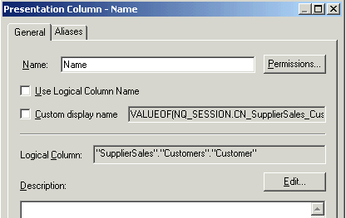
  - Click the Aliases tab.
  - Select the Customer alias and click the Delete button. When an alias is deleted from a repository object, the link from the stored object in the Web Catalog to the metadata is broken. Later in this lab you will modify the SQL generated by a request to restore the link.
  - Click OK.
  - Verify that the column changed to Name in the Presentation layer.
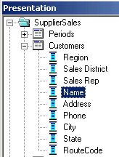
  - Save the repository.
  - Click Yes to check global consistency.
  - Verify that you receive a message indicating that the repository is consistent.
  - Click OK.
  - Select File > Close to close the repository.
  - Select File > Exit to close the Siebel Analytics Administration Tool.
- Edit the logical SQL generated for a Siebel Analytics request to restore the link from the stored object in the Web Catalog to the metadata.
  - Start the Siebel Analytics Web and Siebel Analytics Server services.
  - Log in to Siebel Analytics as Administrator/Administrator.
  - Click the Answers link.
  - In the left pane, select the SQL_Edit request from My Folder.
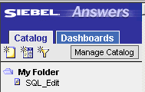
  - You receive a view display error. Expand the error to view the details. The error message indicates that there is an unresolved column: “Customers”.”Customer”. This is the expected error because you changed the name of the Customer column to Name and deleted the alias.
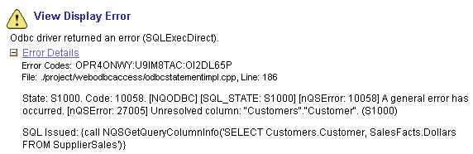
  - Click Modify.
  - Click the Advanced tab.
  - Notice the content in the Request XML field. Requests are stored in the Web Catalog in XML format. In this example, the fourth line of the XML code indicates that the request is still pointing to the Customer column in the Customers presentation catalog.
<saw:column formula="Customers.Customer" columnID="c0"/>
After you modify the SQL in the next steps, you will observe the changes to the XML code in the Request XML field.
  - Notice the error message below the SQL Issued field.
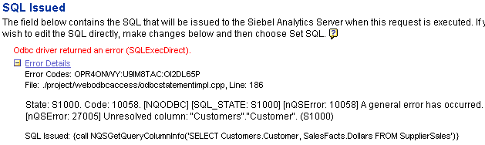
  - Open the SQL_Edit Notepad file you saved in the previous step.
  - In the SQL Issued field, copy and paste the SQL from the SQL_Edit Notepad file.
  - In the SQL Issued field, modify the SQL as follows:
SELECT Customers.Name saw_0, SalesFacts.Dollars saw_1
FROM SupplierSales
WHERE SalesFacts.Dollars > 2000000
ORDER BY saw_0
  - Click Set SQL.
  - Notice that the error message disappears.
  - Notice also that the XML code in the Request XML filed has been updated with the correct information.
  - Save the request. Replace the existing request when prompted.
- Verify your results.
  - Select the Answers link.
  - In the selection pane on the left, click the SQL_Edit request.
  - Verify that you receive the following results:
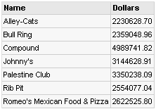
  - Click Modify.
  - Click Advanced.
  - Verify that the correct SQL appears in the SQL Issued field.
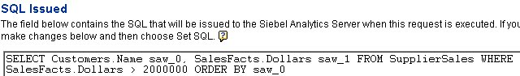
- Leave Siebel Answers open for the next lab.
Lab 1-5 Working with Requests in Microsoft Excel
Goals | To access and work with the results of saved requests in Microsoft Excel.
Scenario | Use the Siebel Analytics toolbar in MS Excel to open a saved request and then work with, save, and refresh the results.
Time | 10 – 15 minutes
Instructions:
- Create the following request and associated filter:
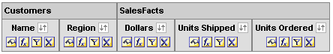
- Check the results. There should be 31 records. The screenshot displays only a portion of the results.
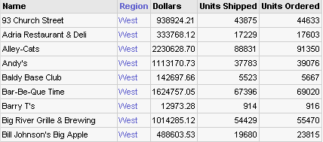
- Save the request with the name MS Excel.
- Open a saved request in the Unformatted Data format from within Microsoft Excel.
  - Select Start > Programs > Microsoft Excel to open Microsoft Excel.
  - Select View > Toolbars > Siebel Analytics. The Siebel Analytics toolbar is displayed.
  - Click the Select Analysis button on the Siebel Analytics toolbar.
  - Log in as Administrator/Administrator. The Select Analysis window appears.
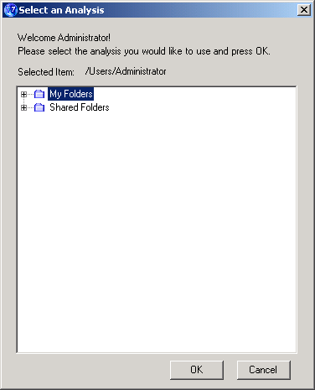
  - Expand My Folders.
  - Select the MS Excel request you saved in an earlier step.
  - Click OK.
  - In the Retrieve drop-down list, select Unformatted Data. This format is the Data view of the criteria for the request. The Data view shows the underlying data only, exclusive of any report formatting that was applied or any views that were assembled using the Compound Layout view in Siebel Answers.
  - Click Continue.
  - The request appears in MS Excel:
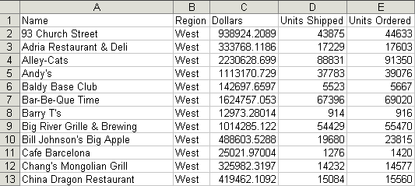
- Open the same request in the Formatted Results format.
  - In the MS Excel worksheet, select the cell A34.
  - Click the Select Analysis button.
  - Log in as Administrator/Administrator.
  - Select My Folders > MS Excel, and click OK.
  - In the Retrieve field, select Formatted Results. This format shows the MS Excel version of the Compound Layout view as assembled for the request in Siebel Answers. This format includes items that are compatible with MS Excel such as column formatting, grand totals, and views included in the Compound Layout view.
  - Click Continue.
  - The request appears within MS Excel.
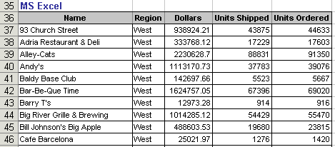
- Leave Siebel Answers open for the next lab.

Lab 1-6 Integrating a Request with MS Excel’s Internet Query Feature
Goals | To integrate a Siebel Answers data request with MS Excel’s Internet Query feature.
Scenario | Run a request from within MS Excel to be used for printing and distributing reports.
Time | 5 – 10 minutes
Instructions:
- Integrate a request with MS Excel’s Internet Query (IQY) feature.
  - If necessary, open the saved MS Excel request in Siebel Answers.
  - Click the Advanced tab.
  - Notice that there are two MS Excel links.
  - Click the first MS Excel link.
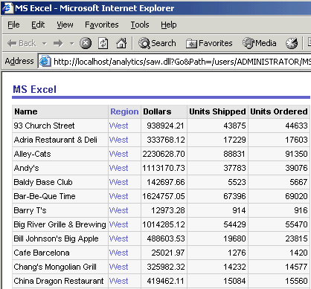
This link returns a page at a time with links to refresh, modify, and view a printable version of the results. This is suitable for use as a Bookmark or Favorite, and within Web pages and portals.
  - Click the second MS Excel link. This link generates and downloads a Web Query (.iqy file), which will prompt for user ID and password, and retrieve the formatted results into Excel.
  - In the File Download window, click Open.
  - Enter Administrator as the Siebel Analytics User ID and click OK.
  - Enter Administrator as the Siebel Analytics Password and click OK.
  - The request appears in MS Excel.
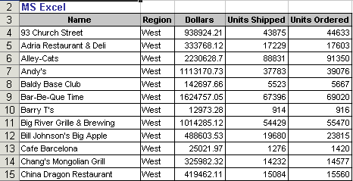
- Close MS Excel without saving your work.
- Leave Siebel Answers open for the next lab.

